Phase 3: Data Modeling & Relationships

# 1. Standard & Custom Objects

In this project, we used standard objects like Account and Contact, and created custom objects such as Student, Course, and Enrollment.

Custom objects were designed to represent our business data model, where Students can enroll in multiple Courses through the Enrollment object.

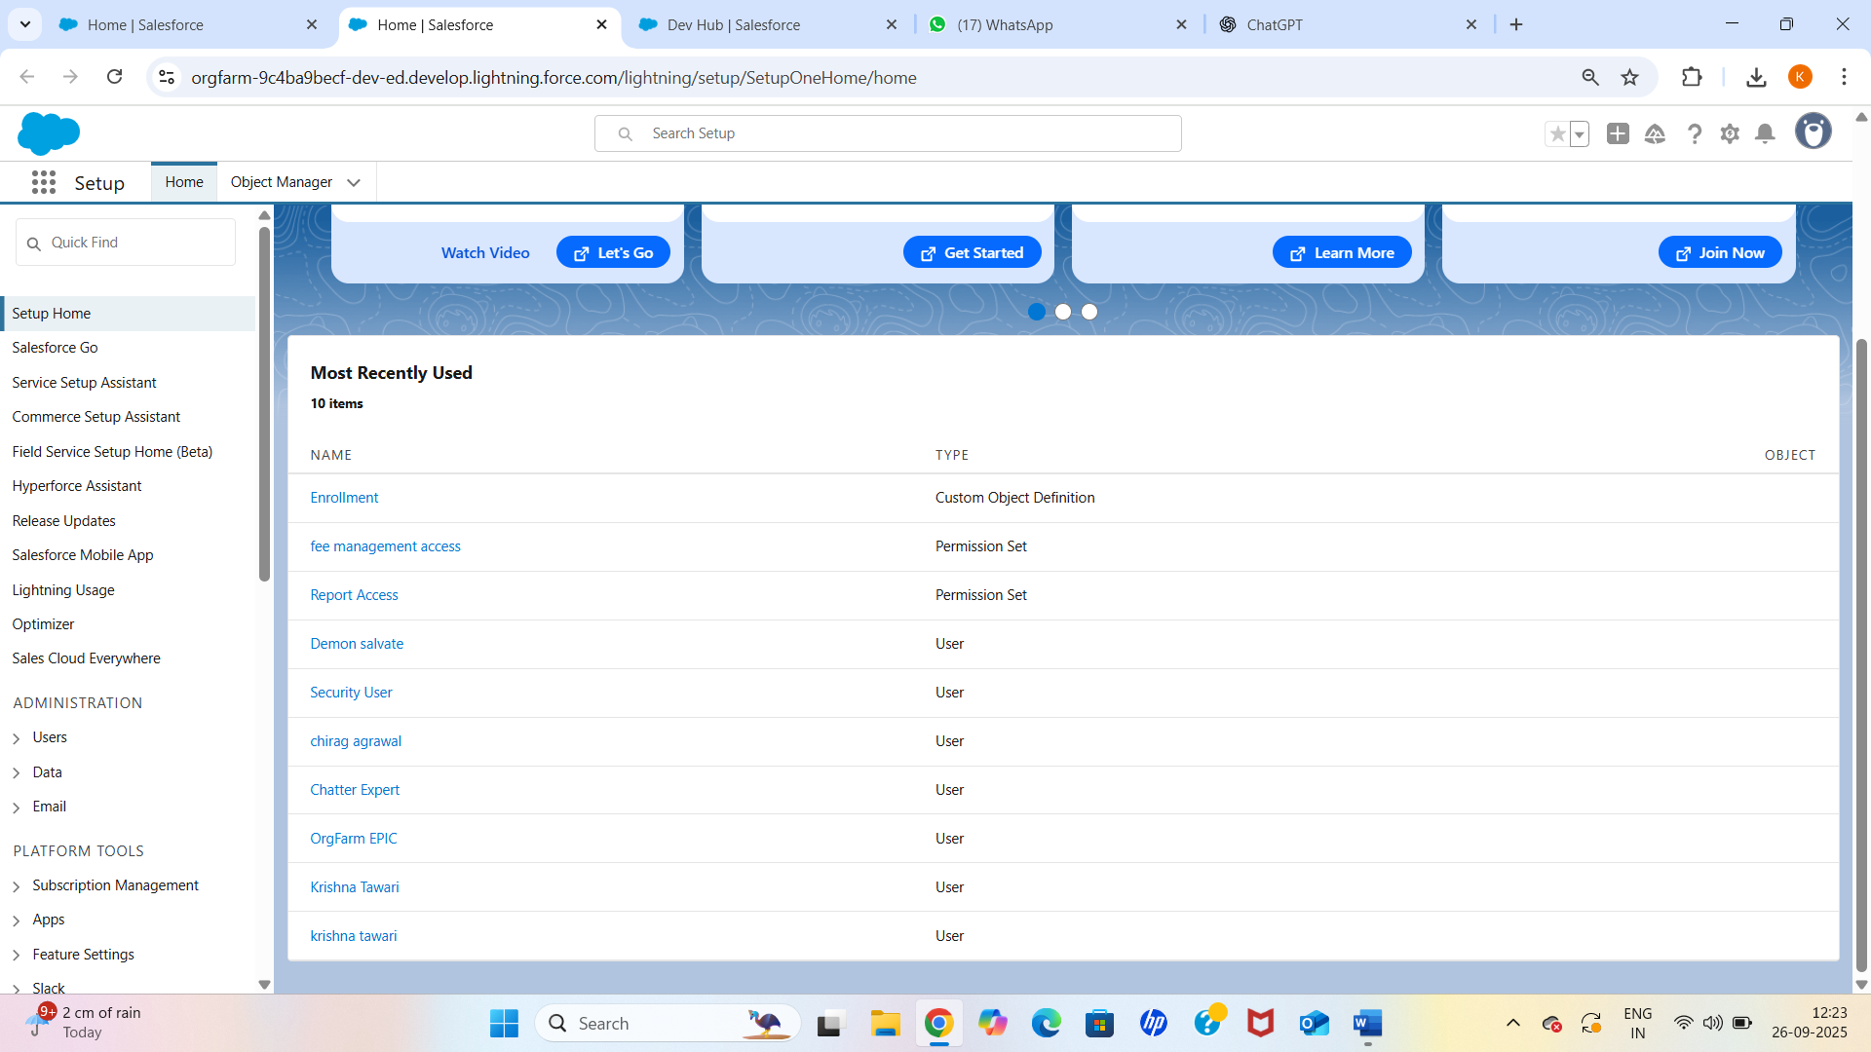

# 2. Fields

Custom fields were added to capture additional data for each object. Examples include:  
- Student: First Name, Last Name, Email, Phone, Department (Picklist), Roll Number.  
- Course: Course Name, Course Code, Duration.  
- Enrollment: Enrollment Date, Status.

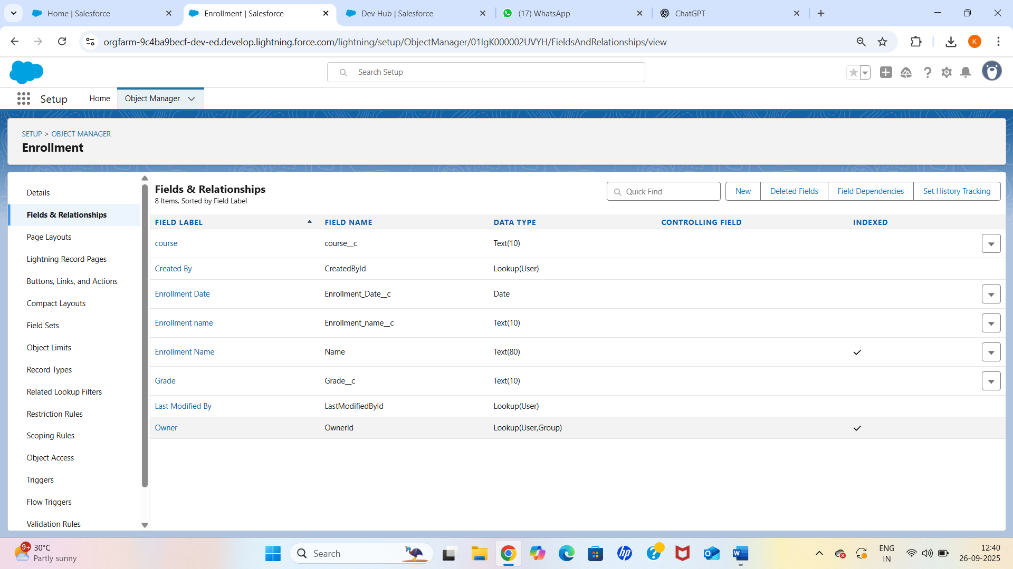

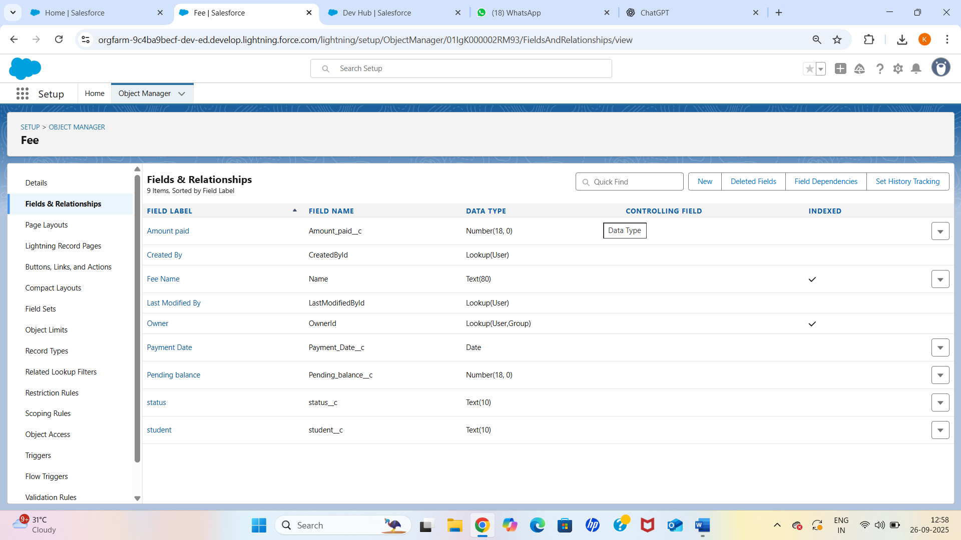

# 3. Record Types

Record types were created on the Course object to differentiate between Online and Offline courses. Each record type uses a specific page layout to show relevant fields.

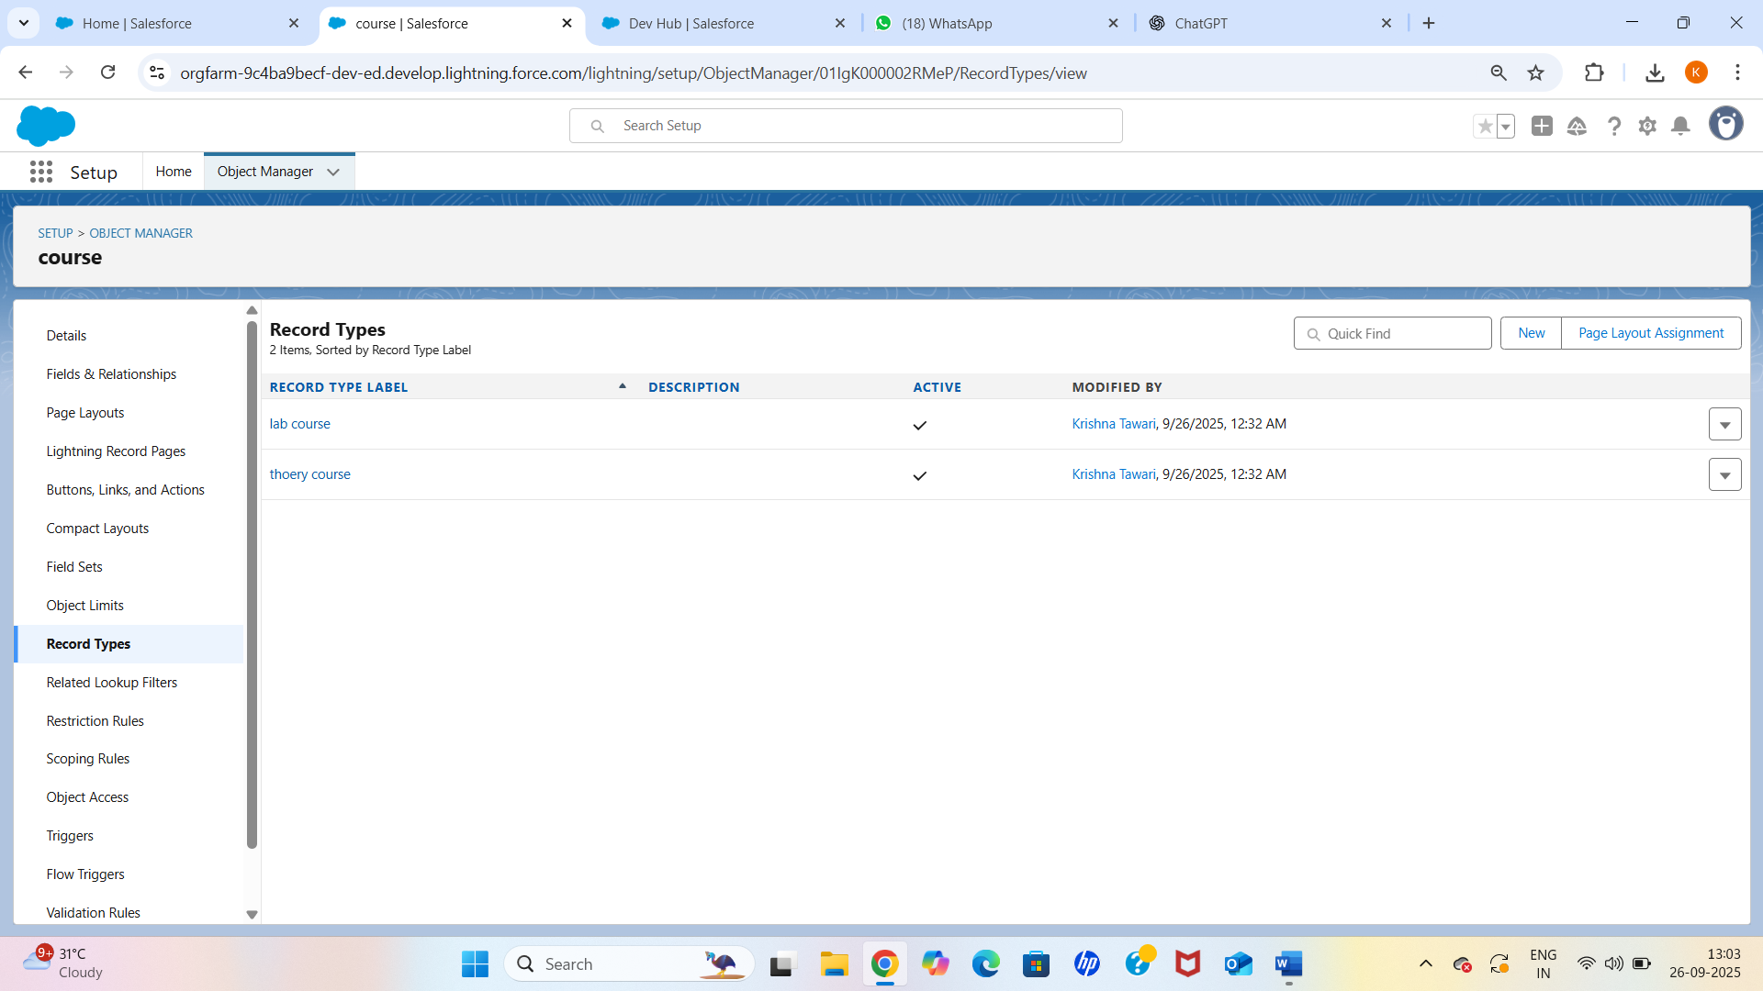

# 4. Page Layouts

Page layouts were customized to organize fields and related lists in a user-friendly way. Different page layouts were assigned based on record type.

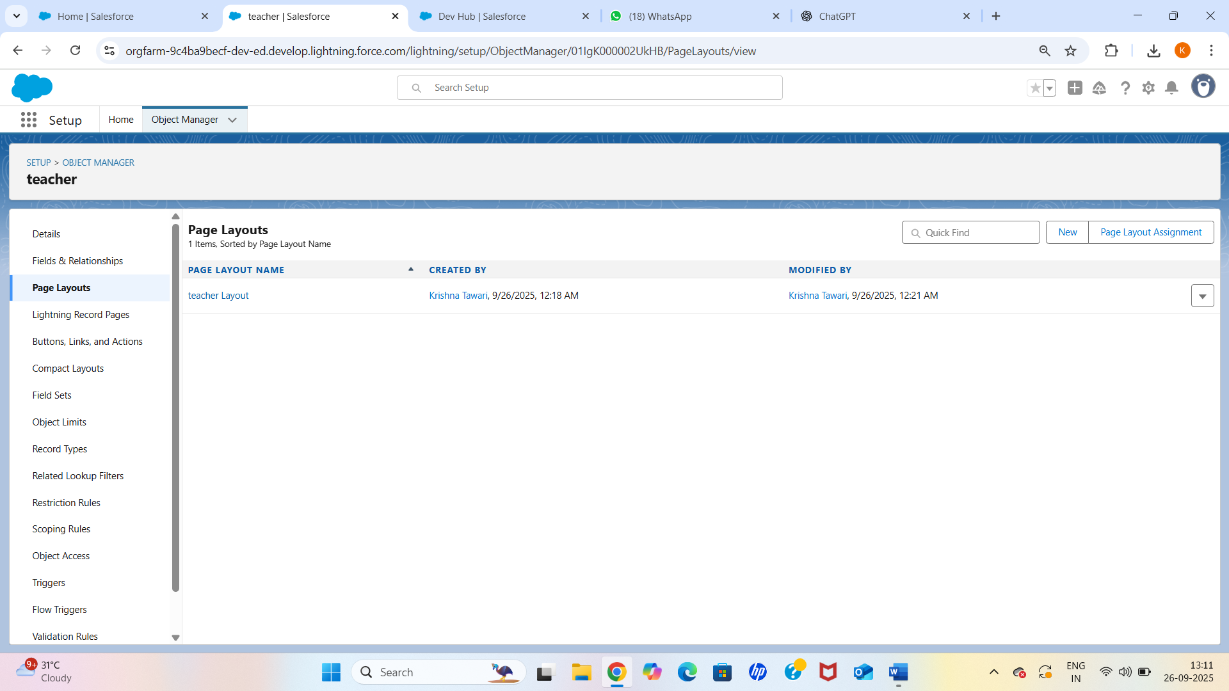

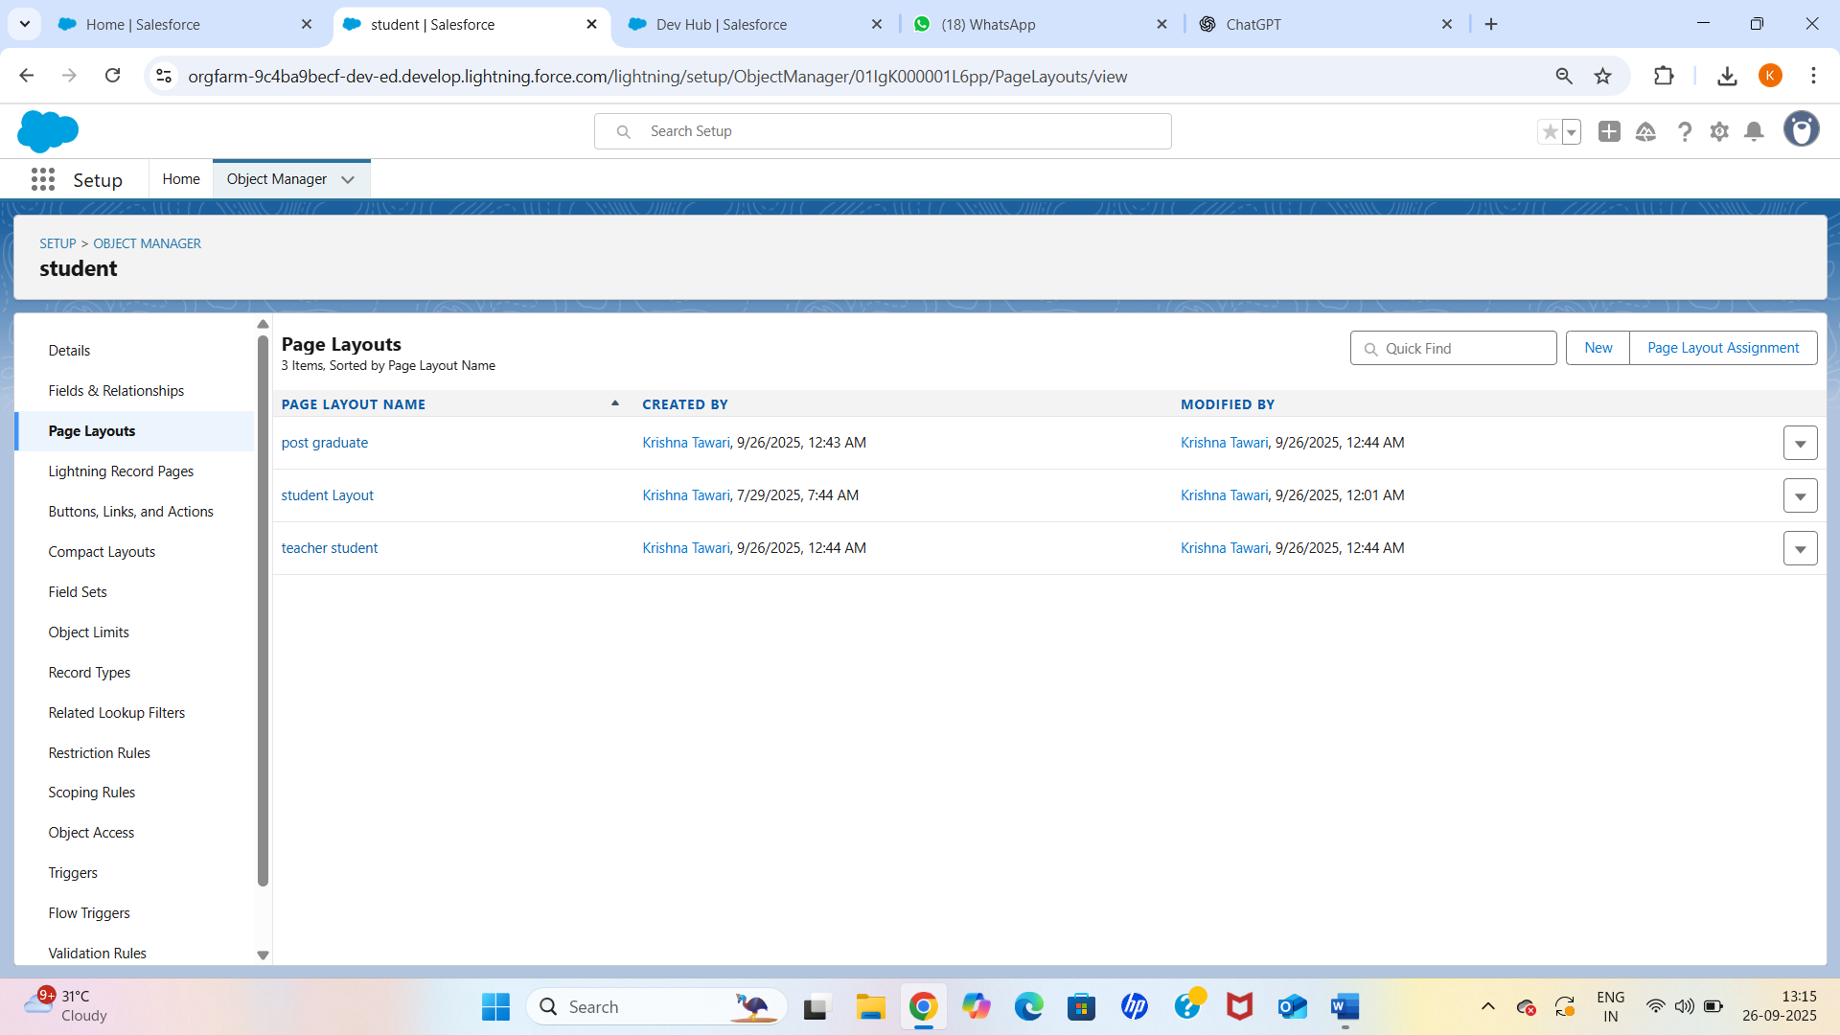

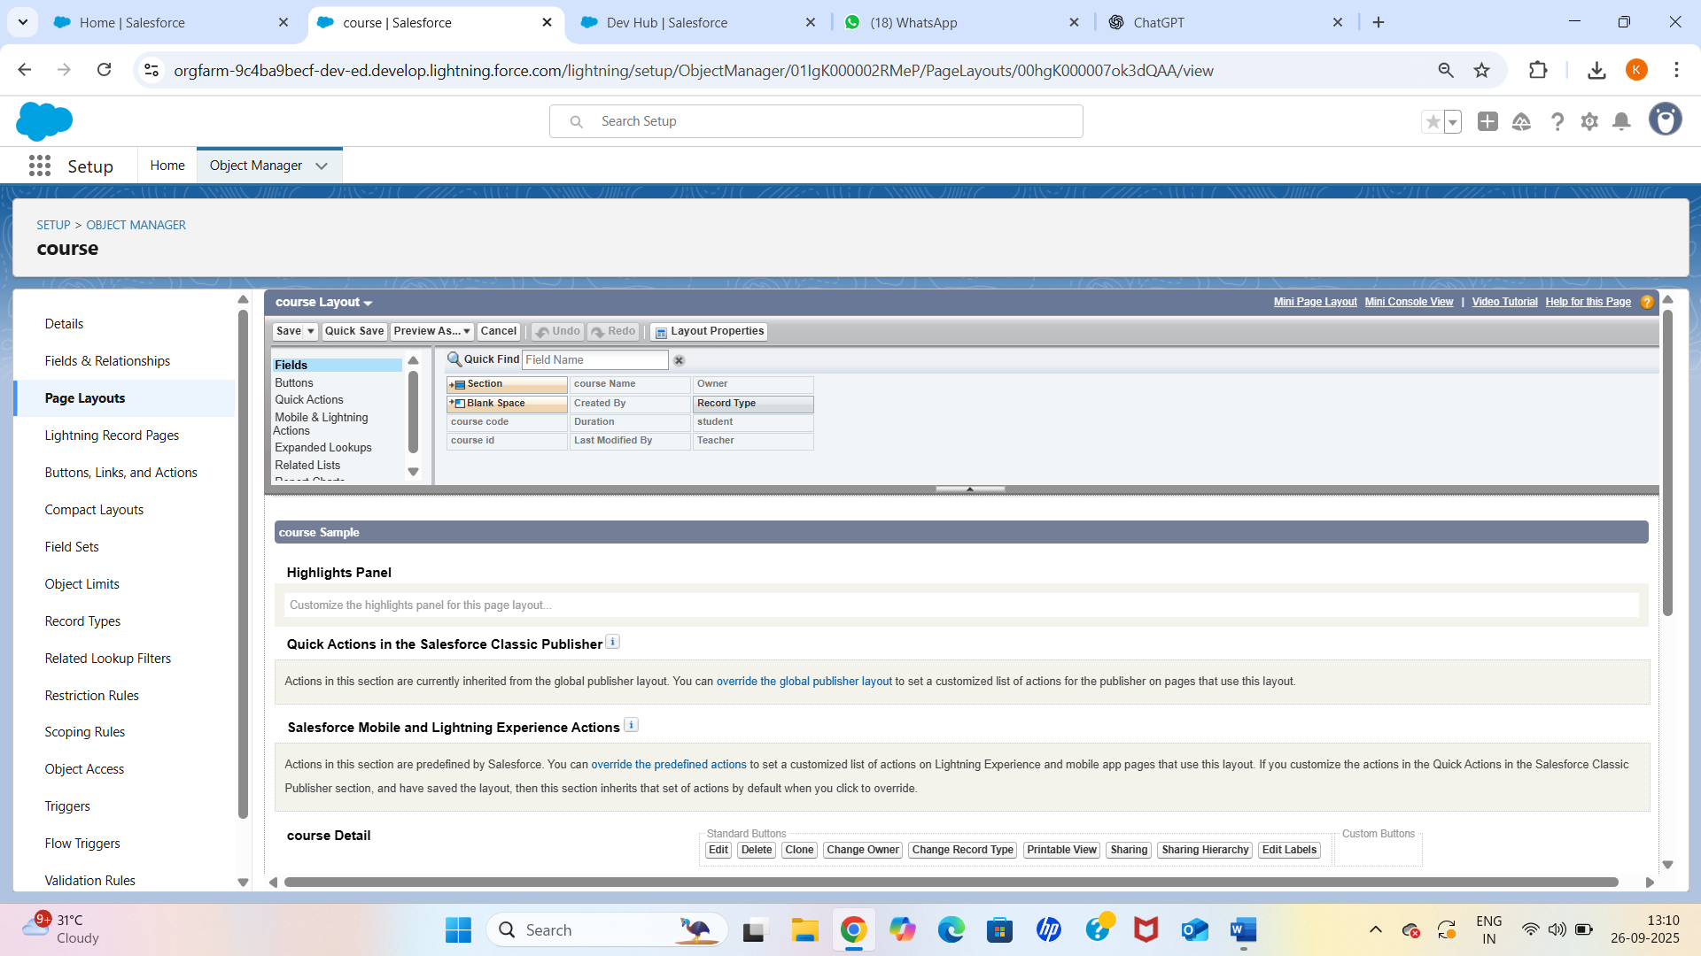

# 5. Compact Layouts

Compact layouts were configured to display key information (Name, Email, Department for Student) in the highlights panel.

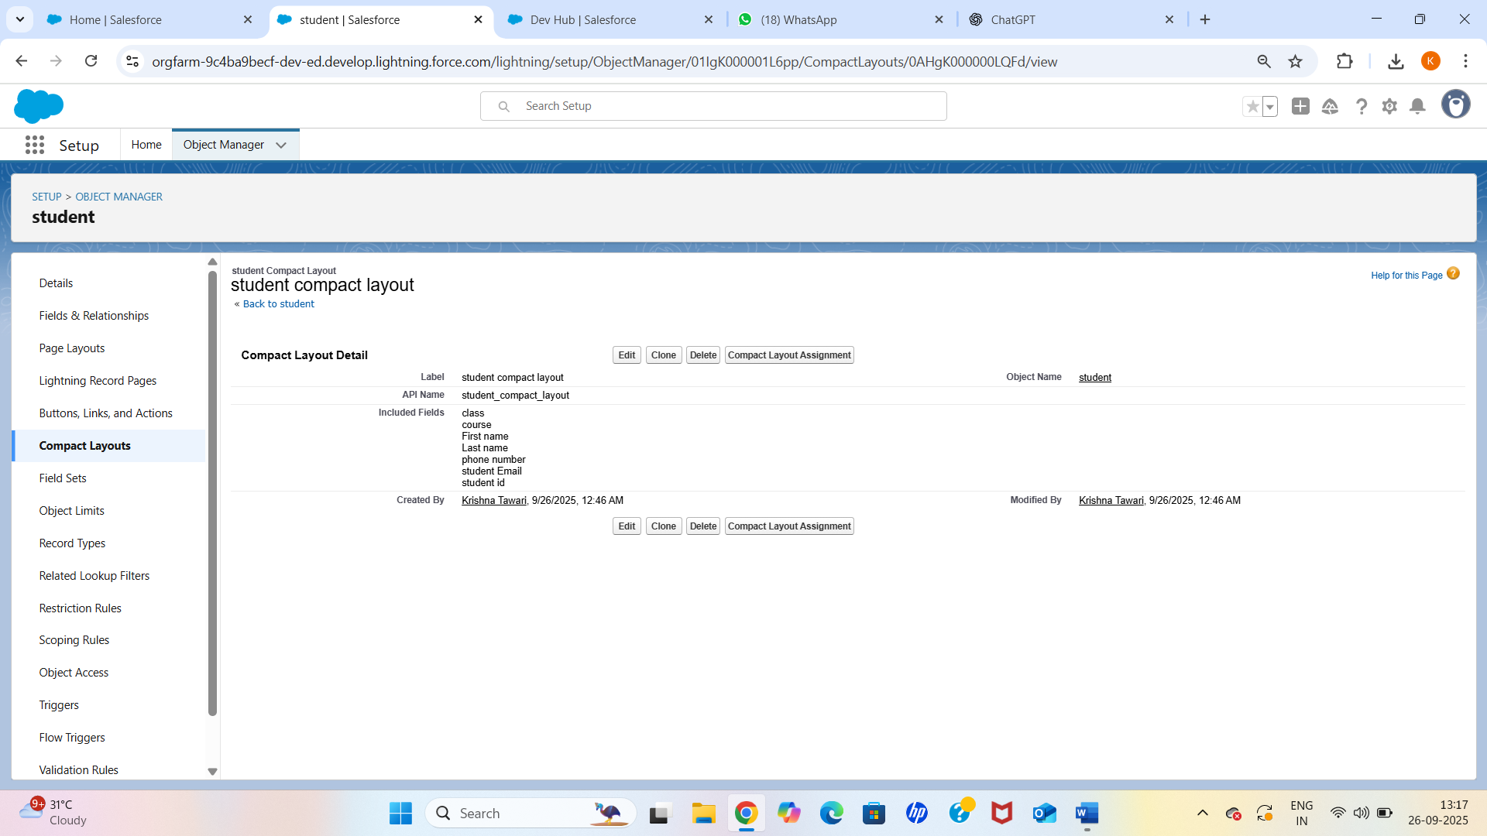

# 6. Schema Builder

Schema Builder was used to visualize relationships between Student, Course, and Enrollment objects, making it easier to validate the data model.

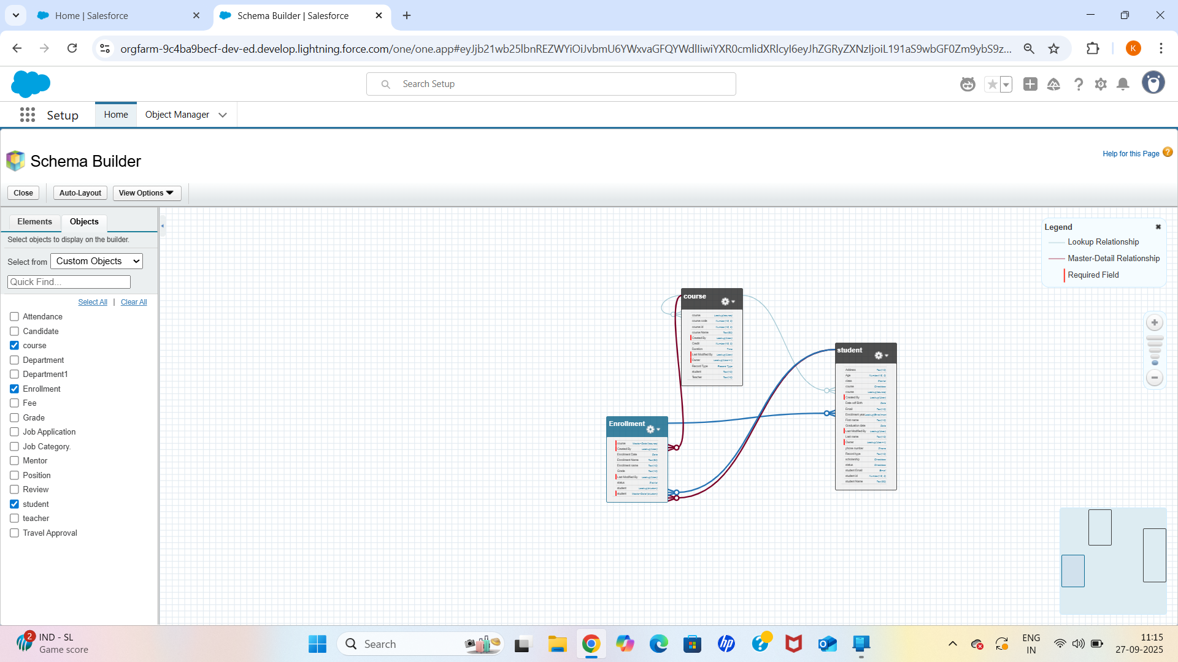

# 7. Lookup vs Master-Detail vs Hierarchical Relationships

Relationships were created as follows:  
- Student ↔ Course: Many-to-Many relationship implemented using the Enrollment junction object.  
- Lookup relationships were used where child records can exist independently.  
- Master-Detail relationships were used for Enrollment to ensure cascading delete behavior and roll-up summary fields.

# 8. Junction Objects

Enrollment object was created as a junction object with two master-detail fields:  
- Student (Master-Detail)  
- Course (Master-Detail)

# 9. External Objects

An external object was configured to fetch reference data about available training materials from an external system, allowing real-time access without data duplication.

